# Prototype MSE model

This document describes the prototype of the management strategy evaluation tool developed in Action C2.2 and represents the documentation section of “D1.2 B: Technical report and open source computer code about the prototype MSE model for strategical planning of multispecies multi-value population management”

## Objectives of the prototype

* Provide a technical basis for simulation evaluation of alternative management strategies
* Exemplify the simulation approach using moose harvesting planning as an illustrative example

## Model structure

An individual based wolf population dynamics model forms the core of the evaluation model. The model simulates the faith of each wolf in space and time. This enables detailed tracking of the demographic and spatial structure of the wolf population through time.

The moose population is modelled with less detail. The moose population is described as moose density and population growth rate at non-harvested state. Existing estimates of spatial variation of the moose density are used as a starting point.

This document provides the basic idea of the modelling approach. Accompanying computer code and comments therein provide more details. Refer to section “R-code” for more details.

### Wolf population dynamics

The wolf population is modelled using an individual based simulation model. The initial state of the simulation is typically set to match the latest result of the annual wolf population assessment. Each wolf belongs to one of the tree categories:

1. **Pups** are individuals that live in the same pack with their parents
2. **Vagrants** are wolves that have left their natal packs, and are seeking to establish their own territory by pairing with another vagrant
3. **Adults** are wolves that have established their own territory as a pair capable of breeding

The faith of each wolf is simulated with a short time step. The length of the time step is adjustable, current implementation uses daily time step. The following checks are performed each day for each wolf:

1. Death. Will the wolf die during this time step? Each individual can have their own probability of death that could vary daily. Current implementation assumes equal mortality within each category, as well as seasonal variability.
2. Breeding. Will the wolf produce offspring today? If the wolf is an adult female with a mate, it can produce a litter. The probability of producing a litter can vary based on the age of the female. If a litter is produced, the number of pups can depend on the age of the female, and on external conditions. In our example the number of pups depends on the number of moose available within the territory. If pups are born, they will be attached to the same pack with their parents.
3. Dispersal. Will a pup leave its natal pack today and become a vagrant? The probability of leaving the pack is based on the age of the pup in our example. Environmental conditions could also be used to affect the dispersal.
4. Pairing. If too vagrants meet during their dispersal, will they establish a territory? In our example vagrants form a new territory at location where they met if 1) they are of opposite sex 2) they are not siblings 3) there is enough space for a territory, i.e., no overlap with existing territories.
5. Dispersal of the pack? Will the pack stay together, or will all the individuals become vagrants. This can happen if one or both of the adults of the pack happen to die. The probability is higher, if both adults die
6. Movement. Where will the wolf move during this time step? The movement is modelled in continuous space using a mean reverting random walk: wolves in packs move only within their territories, whereas vagrants can move around everywhere. However, vagrants enter occupied territories with only a small probability. The movement of all wolves is also guided by environmental covariates: wolves avoid moving to large bodies of water and to areas with a lot of human infrastructure but can do so occasionally.

### Moose model

Moose density estimates are be aggregated to a grid of 30 km x 30 km and transformed to number of moose within each grid cell.

The wolf population model predicts the wolf predation pressure on moose within each grid cell. The moose population within each cell will then be updated using a simple population dynamics as follows:

N[t+1]~Poisson((N[t]-H[t]-W[t])*lambda)

Where N[t] is the number of moose within the cell at year t, H[t] is the number of moose harvested based on a harvest rule, W[t] is the number of moose eaten by wolves and lambda is the population growth rate in case no hunting by humans and wolves takes place. Demographic stochasticity in moose population growth is modelled using a Poisson distribution.

The updated moose population grid is coupled with the wolf territories in the wolf simulation model. The moose grid will be used to calculate the number of moose available as prey within each wolf territory. The size of wolf litter in a territory is dependent on the number of moose available for wolves.

## Using the model: an example

**Note: this is a fictional example with unrealistic parameter values and harvest strategies. The point is just to illustrate how the approach works. Not to be considered as financial or game management advice.**

* Evaluate the short-term (3 years) effects of alternative moose harvesting strategies on the moose population and on the wolf population
* Harvest strategies to be compared
  1. Stop moose hunting completely
  2. Harvest 50% of the moose population every year

The model was simulated forward for three years for each alternative harvest strategy. Because of high computational load of the protype, the simulation was repeated only for three times. Real use will require at least hundreds of repetitions in order to capture uncertainties in a reliable way. Effects on wolf population and moose population will can be described as follows:

### Harvest strategy 1)

Stopping moose hunting completely would enable the moose population to grow within the next three years. Wolf population is not effective enough to control the moose population, but wolf population can also grow due to increased availability of prey affecting the mean litter size.

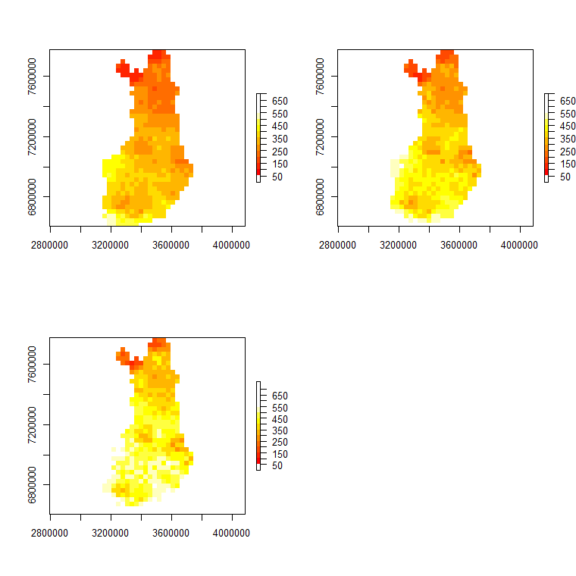

Figure 1. Predicted number of moose within each grid cell of 30 X 30 km under the assumption that moose hunting would stop. First year on top left, third year on bottom left.

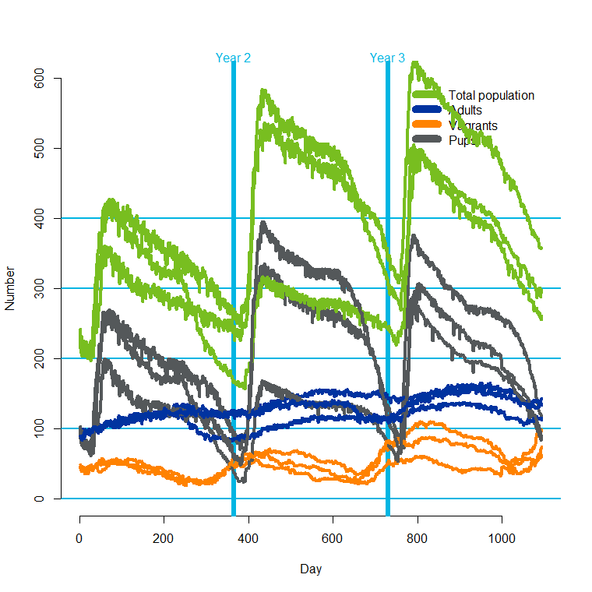

Figure 2. Predicted structure of the wolf population under the assumption of closing the moose hunting for three years.

### Harvest strategy 2)

Removing 50% of the moose population per year would cause a rapid decline in the moose population. Because of reduced prey availability, the wolf litters would get smaller and the wolf population would also decline.

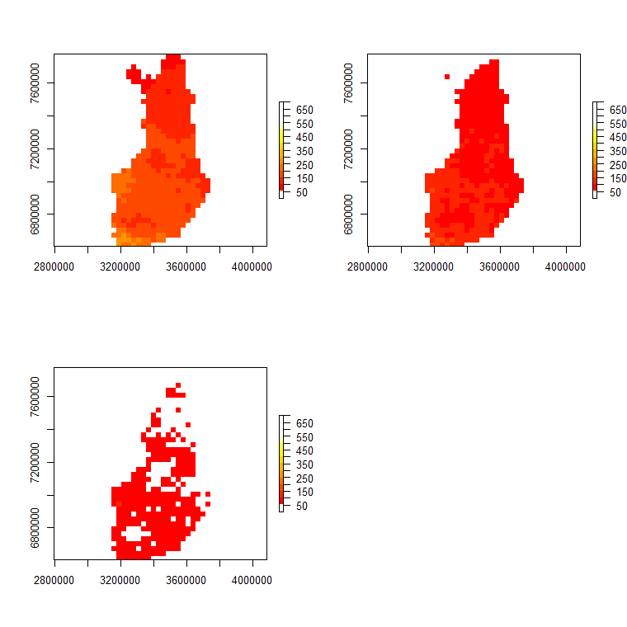

Figure 3. Predicted number of moose within each grid cell of 30 X 30 km under the assumption that moose hunting would take 50% of the population every year. First year on top left, third year on bottom left.

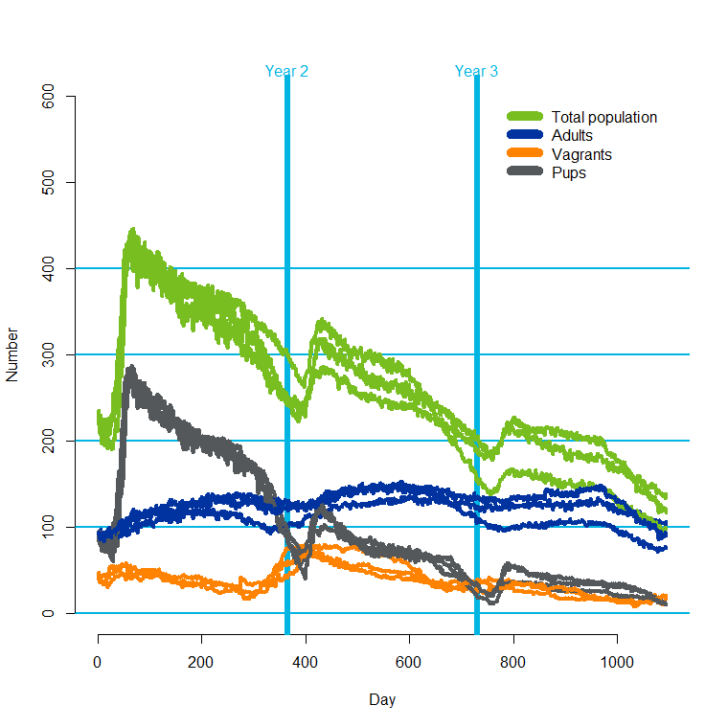

Figure 4. Predicted structure of the wolf population under the assumption of removing 50% of the moose population every year.

## R-code and exemplary data

The prototype is implemented in R. The code and data files are stored in MSE_prototype.zip. Extract the archive to a folder of your choice, such as c:\models. The files are organized as follows:

|  |  |
| --- | --- |
| File | Description |
| mainloop.r | Loads necessary R-packages, GIS-information and necessary data. Transforms the data to required format, specifies parameter values and runs the simulation for specified number of years and iterations.  **Change the working directory in the beginning of this script to match your installation. Check that you have all the required R-packages indicated in the beginning of the script.**  **Executing this script runs the whole simulation.** |
| simulator_functions.r | Includes all the functions that specify the initial state, population dynamics, and utility functions for various computational tasks |
| read_GIS.r | Subscript for reading spatial data |
| mooseraster\mooseraster.r | Loads initial moose density map, and provides functions for moose population dynamics |
| mooseraster\mooseplots.r | Creates maps of moose population from the simulation results. Run this only after a successful simulation. |
| mooseraster\moosedensity.csv | Database of moose density estimates |
| initial_state_territories | Monte Carlo sample of population status from previous assessment |
| indexmap | Mapping of territory indices between wolf population assessment model and territory shapefile |
| predicted_vagrants | Monte Carlo sample of the number of vagrants |
| collared_list.csv | List of collared wolves present at the beginning of the simulation |
| collared_loc.csv | Known locations of collared wolves |
| shapes\reviirit2020 | locations of wolf packs at the initial state |
| shapes\RHP | borders of game management areas |
| shapes\*other files* | various shape files needed |

## Computational issues

Individual based spatial simulation of the wolf population alone is computationally a very intensive task. At the current state of development, simulating the wolf population for 365 days takes about six minutes, so ten years ahead would take an hour. In order to have a good grasp of the uncertainty, the simulation needs to be repeated for at least 1000 times. Thus, a ten year simulation for one of the alternative management strategies would take at least 1000 hours, or about 40 days. However, the simulation can be easily parallelized. Using a computer with 10 CPU:s can cut the simulation time to four days per strategy.

## User interfacing

Because of the currently heavy computational load, on-line use of the tool will be difficult. However, user interfaces can be built for accessing pre-computed results. They can be also used for demonstrative and educational purposes, that enhance the understanding about the ecological system.

First versions of the model are in the form of R code, and an expert user/developer is needed as a user interface.

## Piloting in moose management areas in 2021

The concept of the model will be presented in selected moose management areas, and examples will be demonstrated using pre-computed results from the prototype model.

## Further development directions

Model structure

* Accounting for other predator and prey species: bear and white-tailed deer
* Density dependence for all species needed for longer model runs
* Moose population structure: males, females, calves
* Connecting to other moose related performance statistics: forest damages, traffic accidents, hunting dogs killed by wolves
* Building modules for other management strategies and performance statistics defined by stakeholders

Computation

* Rewrite the model in Julia-language (faster than R)
* Research ways to use a longer time step than a day in wolf population dynamics
* Build an emulator that mimics the simulator: gives essentially the same results but is much faster. Gaussian processes and Bayesian networks

User interfacing

* Depends on the success in speeding up the computation
* Webapps for illustrating pre-calculated results, integration to existing systems
* If speed is ok: interactive input using e.g Shiny-package. See SalmonSimulator as an example: <https://smshiny.shinyapps.io/SalmonSimulator/>